C++多态编程(10003809173j)
班级:信2007-2 学号:20203907 姓名:周朝勇
一 实验目的
- 使学生理解多重继承的概念；
- 使学生理解多态的作用，掌握运算符重载为成员函数和友元函数的方法；
- 使学生理解虚函数的作用和用法；
- 使学生能够对使用多态机制的简单程序写出程序结果；
二 实验环境
- 所需硬件环境为微机；
- 所需软件环境为Microsoft Visual C++ 6.0或Code::Blocks ；
三 实验内容
（一）、设计并实现加法器类Adder【CPP0023】
【源代码】
此处附上完整的程序源代码，要求包括Person类、Student类、Teacher类和main()，要有必要的注释，不能是图片形式。
#include <iostream>
using namespace std;

/*请在这里填写答案*/
class Adder{
private:
int num;
public:
Adder(int x=0){
num=x;
cout<<"Adder Constructor run"<<endl;
}
Adder(const Adder &a){
num=a.num;
cout<<"Adder CopyConstructor run"<<endl;
}
~Adder(){
cout<<"Adder Destructor run"<<endl;
}
void setNum(int x){
num=x;
}
int getNum() const{
return num;
}
Adder operator + (Adder &a){
Adder t;
t.num=num+a.num;
return t;
}
Adder operator ++ (int){
Adder t=*this;
num++;
return t;
}
Adder &operator ++ (){
++num;
return *this;
}
void show() const{
cout<<"Adder("<<num<<")"<<endl;
}
};
//主函数
int main(void){
int x;
Adder a1,a2(a1);
cin>>x;
(a1++).show();
a1.show();
a2.setNum(x);
(++a2).show();
a2.show();
(a1+a2).show();
return 0;
}
【运行测试】
此处附上程序运行的测试截图
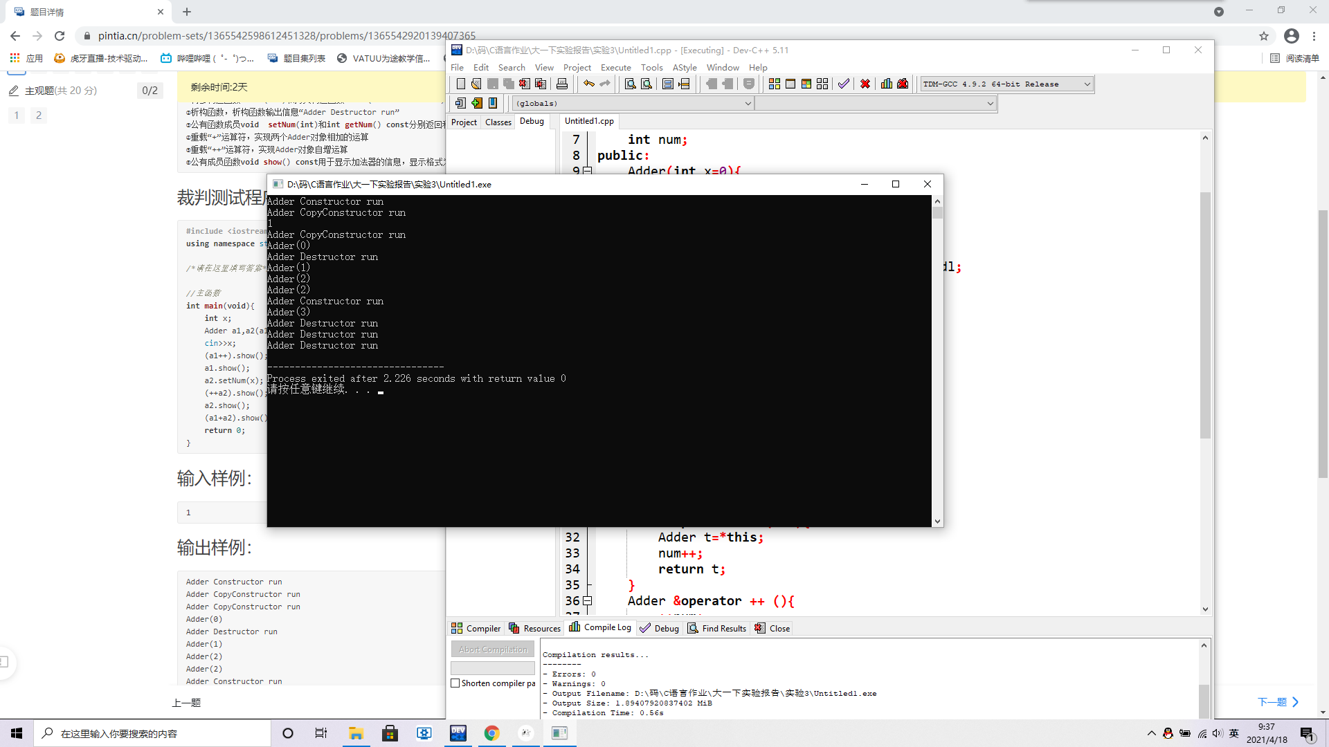
（二）、设计并实现大数类BigNum【CPP0024】
【源代码】
此处附上完整的程序源代码，要求包括Person类、Student类、Teacher类和main()，要有必要的注释，不能是图片形式。
#include <iostream>
using namespace std;
#define N 100

class BigNum{
private:
char num[N];
public:
BigNum(char c[]="+0")
{
int i=0;
int k=0;
if(c[0]!='-'&&c[0]!='+')
{
num[0]='+';
i++;
}
while(c[k]!='\0'){
num[i]=c[k];
i++;
k++;
}
num[i]='\0';
cout<<"BigNum Constructor run"<<endl;
}
BigNum(BigNum&);
~BigNum(){
cout<<"BigNum Destructor run"<<endl;
}
void setNum(char c[]);
char const *getNum(void) const;
BigNum operator+(BigNum&);
BigNum operator-(BigNum&);
void show() const;
};
void BigNum::show()const{
cout<<"BigNum"<<"(";
cout<<num<<")"<<endl;
}
BigNum::BigNum(BigNum&t){
int i=0;
while(t.num[i]!='\0'){
num[i]=t.num[i];
i++;
}
num[i]='\0';
cout<<"BigNum CopyConstructor run"<<endl;
}
void BigNum::setNum(char c[]){
int i=0;
int k=0;
if(c[0]!='-'&&c[0]!='+')
{
num[0]='+';
i++;
}
while(c[k]!='\0'){
num[i]=c[k];
i++;
k++;
}
num[i]='\0';
}
char const *BigNum::getNum()const{
return num;
}
BigNum BigNum::operator+(BigNum&t){
BigNum q=t;
BigNum s;
BigNum z=s;
if(num[1]=='0'&&t.num[1]=='0')
{
z.num[0]='0';
z.num[1]='\0';
return z;
}
int c=1;
while(c<99)
{
z.num[c]='0';
c++;
}
z.num[c]='\0';
int i1=0,i2=0;
while(num[i1]!='\0') i1++;
while(t.num[i2]!='\0') i2++;
int i11=i1,i22=i2;
if(i11>i22) {
t.num[i1]='\0';
int k=i1-i2;
while(k!=0){
int t1=i1-1;
while(t1!=1){
t.num[t1]=t.num[t1-1];
t1--;
}
k--;
}
int i=1;
while(i<=i11-i22)
{
t.num[i]='0';
i++;
}
}
else if(i11<i22){
t.num[i2]='\0';
int k=i2-i1;
while(k!=0){
int t1=i2-1;
while(t1!=1){
num[t1]=num[t1-1];
t1--;
}
k--;
}
int i=1;
while(i<=i22-i11)
{

num[i]='0';
i++;
}
}
//分情况。
if(num[0]=='+')
{
if(t.num[0]=='+')
{
int i=1;
int j=1;
while(num[i]!='\0'&&t.num[i]!='\0'){
s.num[j]=num[i]+t.num[i]-48;
j++;
i++;
}
s.num[j]='\0';
j--;
int T;
T=j+1;
z.num[T+1]='\0';
int jinwei;
while(j!=0){
jinwei=0;
z.num[T]=((int)s.num[j]-48)%10+z.num[T];
jinwei=((int)z.num[T]-48)/10;
z.num[T]=(((int)z.num[T])-48)%10+48;
z.num[T-1]=((int)z.num[T-1]-48)+((int)s.num[j]-48)/10+48+jinwei;
T--;
j--;
}
if((int)z.num[2]-48==10){
z.num[1]='1';
z.num[2]='0';
}
if(z.num[1]=='0'){
int k=1;
while(z.num[k]!='\0')
{
z.num[k]=z.num[k+1];
k++;
}
}
return z;
}
if(t.num[0]=='-'){
bool flag=true;
int K=1;
while(1){
if(num[K]>t.num[K])
{
flag=true;
break;
}
else if(num[K]<t.num[K])
{
flag=false;
break;
}
else K++;

if(num[K]=='\0') break;
}
if(!flag) {
s.num[0]='-';
z.num[0]='-';
}
int i;
i=i11>i22?i11:i22;
i=i-1;
int j=i;
int temp=j;
if(!flag)
{
int temp[101];
int K=1;
while(num[K]!='\0')
{
temp[K]=t.num[K];
t.num[K]=num[K];
num[K]=temp[K];
K++;
}
}
while(j!=0){
s.num[j]=num[i]-t.num[i]+48;
j--;
i--;
}
j=temp+1;
s.num[j]='\0';
j--;
int T;
T=j+1;
z.num[T+1]='\0';
while(j!=0){
if(s.num[j]<'0')
{
z.num[T]=(int)s.num[j]+10+z.num[T]-48;
s.num[j-1]=s.num[j-1]-1;
}
else{
z.num[T]=(int)s.num[j];
}
T--;
j--;
}
while(z.num[1]=='0'){
int k=1;
while(z.num[k]!='\0')
{
z.num[k]=z.num[k+1];
k++;
}
}
return z;
}
}
if(num[0]=='-')
{
if(t.num[0]=='+'){
bool flag=true;
int K=1;
while(1){
if(t.num[K]>num[K])
{
flag=true;
break;
}
else if(t.num[K]<num[K])
{
flag=false;
break;
}
else K++;

if(num[K]=='\0') break;
}
if(!flag) {
s.num[0]='-';
z.num[0]='-';
}
int i;
i=i11>i22?i11:i22;
i=i-1;
int j=i;
int temp=j;
if(!flag)
{
int temp[101];
int K=1;
while(t.num[K]!='\0')
{
temp[K]=num[K];
num[K]=t.num[K];
t.num[K]=temp[K];
K++;
}
}
while(j!=0){
s.num[j]=t.num[i]-num[i]+48;
j--;
i--;
}
j=temp+1;
s.num[j]='\0';
cout<<s.num<<endl;
j--;
int T;
T=j+1;
z.num[T+1]='\0';
while(j!=0){
if(s.num[j]<'0')
{
z.num[T]=(int)s.num[j]+10+z.num[T]-48;
s.num[j-1]=s.num[j-1]-1;
}
else{
z.num[T]=(int)s.num[j];
}
T--;
j--;
}
while(z.num[1]=='0'){
int k=1;
while(z.num[k]!='\0')
{
z.num[k]=z.num[k+1];
k++;
}
}
return z;
}
}
if(t.num[0]=='-'){
int i=1;
int j=1;
z.num[0]='-';
while(num[i]!='\0'&&t.num[i]!='\0'){
s.num[j]=num[i]+t.num[i]-48;
j++;
i++;
}
s.num[j]='\0';
j--;
int T;
T=j+1;
z.num[T+1]='\0';
int jinwei;
while(j!=0){
jinwei=0;
z.num[T]=((int)s.num[j]-48)%10+z.num[T];
jinwei=((int)z.num[T]-48)/10;
z.num[T]=(((int)z.num[T])-48)%10+48;
z.num[T-1]=((int)z.num[T-1]-48)+((int)s.num[j]-48)/10+48+jinwei;
T--;
j--;
}
if((int)z.num[2]-48==10){
z.num[1]='1';
z.num[2]='0';
}
if(z.num[1]=='0'){
int k=1;
while(z.num[k]!='\0')
{
z.num[k]=z.num[k+1];
k++;
}
}
return z;
}
}

BigNum BigNum::operator-(BigNum &t)
{

BigNum s;
BigNum z=s;
bool flaga=false;
int l=0;
while(num[l]==t.num[l]){
l++;
if(num[l]=='\0'&&t.num[l]=='\0'){
flaga=true;
}
}
if(flaga){
z.num[0]='0';
z.num[1]='\0';
return z;
}
int c=1;
while(c<99)
{
z.num[c]='0';
c++;
}
z.num[c]='\0';
int i1=0,i2=0;
while(num[i1]!='\0') i1++;
while(t.num[i2]!='\0') i2++;
int i11=i1,i22=i2;
if(i11>i22) {
t.num[i1]='\0';
int k=i1-i2;
while(k!=0){
int t1=i1-1;
while(t1!=1){
t.num[t1]=t.num[t1-1];
t1--;
}
k--;
}
int i=1;
while(i<=i11-i22)
{
t.num[i]='0';
i++;
}
}
else if(i11<i22){
t.num[i2]='\0';
int k=i2-i1;
while(k!=0){
int t1=i2-1;
while(t1!=1){
num[t1]=num[t1-1];
t1--;
}
k--;
}
int i=1;
while(i<=i22-i11)
{

num[i]='0';
i++;
}
}
if(num[0]=='+')
{
if(t.num[0]=='+'){
bool flag=true;
int K=1;
while(1){
if(num[K]>t.num[K])
{
flag=true;
break;
}
else if(num[K]<t.num[K])
{
flag=false;
break;
}
else K++;

if(num[K]=='\0') break;
}
if(!flag) {
s.num[0]='-';
z.num[0]='-';
}
int i;
i=i11>i22?i11:i22;
i=i-1;
int j=i;
int temp=j;
if(!flag)
{
int temp[101];
int K=1;
while(num[K]!='\0')
{
temp[K]=t.num[K];
t.num[K]=num[K];
num[K]=temp[K];
K++;
}
}
while(j!=0){
s.num[j]=num[i]-t.num[i]+48;
j--;
i--;
}
j=temp+1;
s.num[j]='\0';
//cout<<s.num<<endl;
j--;
int T;
T=j+1;
z.num[T+1]='\0';
while(j!=0){
if(s.num[j]<'0')
{
z.num[T]=(int)s.num[j]+10+z.num[T]-48;
s.num[j-1]=s.num[j-1]-1;
}
else{
z.num[T]=(int)s.num[j];
}
T--;
j--;
}
while(z.num[1]=='0'){
int k=1;
while(z.num[k]!='\0')
{
z.num[k]=z.num[k+1];
k++;
}
}
return z;
}
if(t.num[0]=='-'){
int i=1;
int j=1;
while(num[i]!='\0'&&t.num[i]!='\0'){
s.num[j]=num[i]+t.num[i]-48;
j++;
i++;
}
s.num[j]='\0';
j--;
int T;
T=j+1;
z.num[T+1]='\0';
int jinwei;
while(j!=0){
jinwei=0;
z.num[T]=((int)s.num[j]-48)%10+z.num[T];
jinwei=((int)z.num[T]-48)/10;
z.num[T]=(((int)z.num[T])-48)%10+48;
z.num[T-1]=((int)z.num[T-1]-48)+((int)s.num[j]-48)/10+48+jinwei;
T--;
j--;
}
if((int)z.num[2]-48==10){
z.num[1]='1';
z.num[2]='0';
}
if(z.num[1]=='0'){
int k=1;
while(z.num[k]!='\0')
{
z.num[k]=z.num[k+1];
k++;
}
}
return z;

}
}
if(num[0]=='-')
{
if(t.num[0]=='+'){
int i=1;
int j=1;
z.num[0]='-';
while(num[i]!='\0'&&t.num[i]!='\0'){
s.num[j]=num[i]+t.num[i]-48;
j++;
i++;
}
s.num[j]='\0';
j--;
int T;
T=j+1;
z.num[T+1]='\0';
int jinwei;
while(j!=0){
jinwei=0;
z.num[T]=((int)s.num[j]-48)%10+z.num[T];
jinwei=((int)z.num[T]-48)/10;
z.num[T]=(((int)z.num[T])-48)%10+48;
z.num[T-1]=((int)z.num[T-1]-48)+((int)s.num[j]-48)/10+48+jinwei;
T--;
j--;
}
if((int)z.num[2]-48==10){
z.num[1]='1';
z.num[2]='0';
}
if(z.num[1]=='0'){
int k=1;
while(z.num[k]!='\0')
{
z.num[k]=z.num[k+1];
k++;
}
}
return z;
}
if(t.num[0]=='-'){
bool flag=true;
int K=1;
while(1){
if(t.num[K]>num[K])
{
flag=true;
break;
}
else if(t.num[K]<num[K])
{
flag=false;
break;
}
else K++;

if(num[K]=='\0') break;
}
if(!flag) {
s.num[0]='-';
z.num[0]='-';
}
int i;
i=i11>i22?i11:i22;
i=i-1;
int j=i;
int temp=j;
if(!flag)
{
int temp[101];
int K=1;
while(t.num[K]!='\0')
{
temp[K]=num[K];
num[K]=t.num[K];
t.num[K]=temp[K];
K++;
}
}
while(j!=0){
s.num[j]=t.num[i]-num[i]+48;
j--;
i--;
}
j=temp+1;
s.num[j]='\0';
cout<<s.num<<endl;
j--;
int T;
T=j+1;
z.num[T+1]='\0';
while(j!=0){
if(s.num[j]<'0')
{
z.num[T]=(int)s.num[j]+10+z.num[T]-48;
s.num[j-1]=s.num[j-1]-1;
}
else{
z.num[T]=(int)s.num[j];
}
T--;
j--;
}
while(z.num[1]=='0'){
int k=1;
while(z.num[k]!='\0')
{
z.num[k]=z.num[k+1];
k++;
}
}
return z;
}
}
}
//主函数
int main(void){
char c[100],op;
cin>>c;
BigNum b1(c),b2(b1);
b1.show();
cin>>c;
b2.setNum(c);
b2.show();
cin>>op;
if(op=='+') (b1+b2).show();
if(op=='-') (b1-b2).show();
return 0;
}
【运行测试】
此处附上程序运行的测试截图
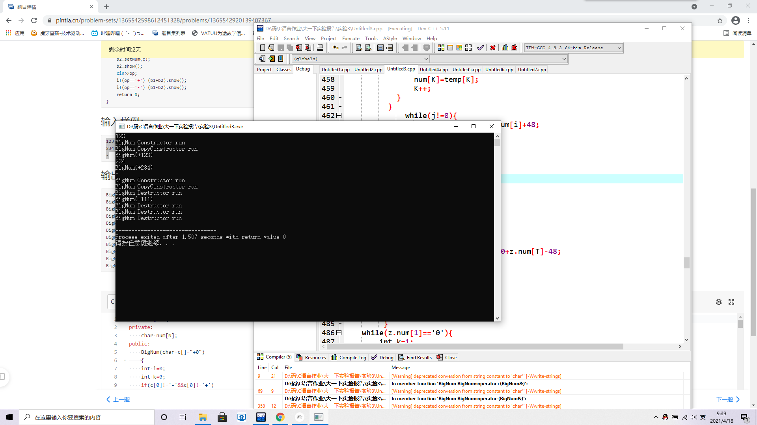
（三）、以点类Point及平面图形类Plane为基础设计圆类Circle【CPP0025】
【源代码】
此处附上完整的程序源代码，要求包括Person类、Student类、Teacher类和main()，要有必要的注释，不能是图片形式。
#include <iostream>
using namespace std;
//点类Point
class Point{
private:
double x;
double y;
public:
Point(double xv=0,double yv=0);/*构造函数*/
Point(const Point &p); /*拷贝构造*/
~Point(); /*析构函数*/
virtual void show()const; /*显示*/
void setX(double xv); /*设置X坐标*/
void setY(double yv); /*设置Y坐标*/
double getX() const; /*获取X坐标*/
double getY() const; /*获取Y坐标*/
};
Point::Point(const double xv,const double yv){/*构造函数*/
x=xv;
y=yv;
cout<<"Point Constructor run"<<endl;
}
Point::Point(const Point &p){/*拷贝构造*/
x=p.x;
y=p.y;
cout<<"Point CopyConstructor run"<<endl;
}
Point::~Point(){/*析构函数*/
cout<<"Point Destructor run"<<endl;
}
void Point::show() const{/*显示*/
cout<<"Point(X="<<x<<",Y="<<y<<")";
}
void Point::setX(double xv){/*设置X坐标*/
x=xv;
}
void Point::setY(double yv){/*设置Y坐标*/
y=yv;
}
double Point::getX() const{/*获取X坐标*/
return x;
}
double Point::getY() const{/*获取Y坐标*/
return y;
}
class Plane{/*平面图形基类*/
public:
virtual double length()const=0;/*周长*/
virtual double area()const=0; /*面积*/
};

/*请在这里填写答案*/

class Circle:public Plane,public Point{
private:
double x;
double y;
double radius;
protected:
static double PI;
public:
Circle(double x=0,double y=0,double r=0):Point(x,y){
radius=r;
cout<<"Circle Constructor run"<<endl;
}
Circle(const Circle &t):Point(t){
radius=t.radius;
cout<<"Circle CopyConstructor run"<<endl;
}
~Circle(){
cout<<"Circle Destructor run"<<endl;
}
void setR(double r){
radius=r;
}
double getR() const{
return radius;
}
void show() const{
cout<<"Circle(Point(X="<<getX()<<",Y="<<getY()<<"),Radius="<<radius<<")";
}
double area() const{
return PI*radius*radius;
}
double length() const{
return 2*PI*radius;
}
};

double Circle::PI=3.14159;
void show(Point *p){/*点基类的显示函数*/
p->show();
}
void length(Plane *p){/*平面图形的周长函数*/
cout<<"Length="<<p->length()<<endl;
}
void area(Plane &p){/*平面图形的面积函数*/
cout<<"Area="<<p.area()<<endl;
}
//主函数
int main(void){
double x,y,r;
Circle c1,c2(c1);
show(&c1);
cout<<endl;
area(c1);
length(&c1);
cin>>x>>y>>r;
c2.setX(x);
c2.setY(y);
c2.setR(r);
show(&c2);
cout<<endl;
area(c2);
length(&c2);
}

【运行测试】
此处附上程序运行的测试截图
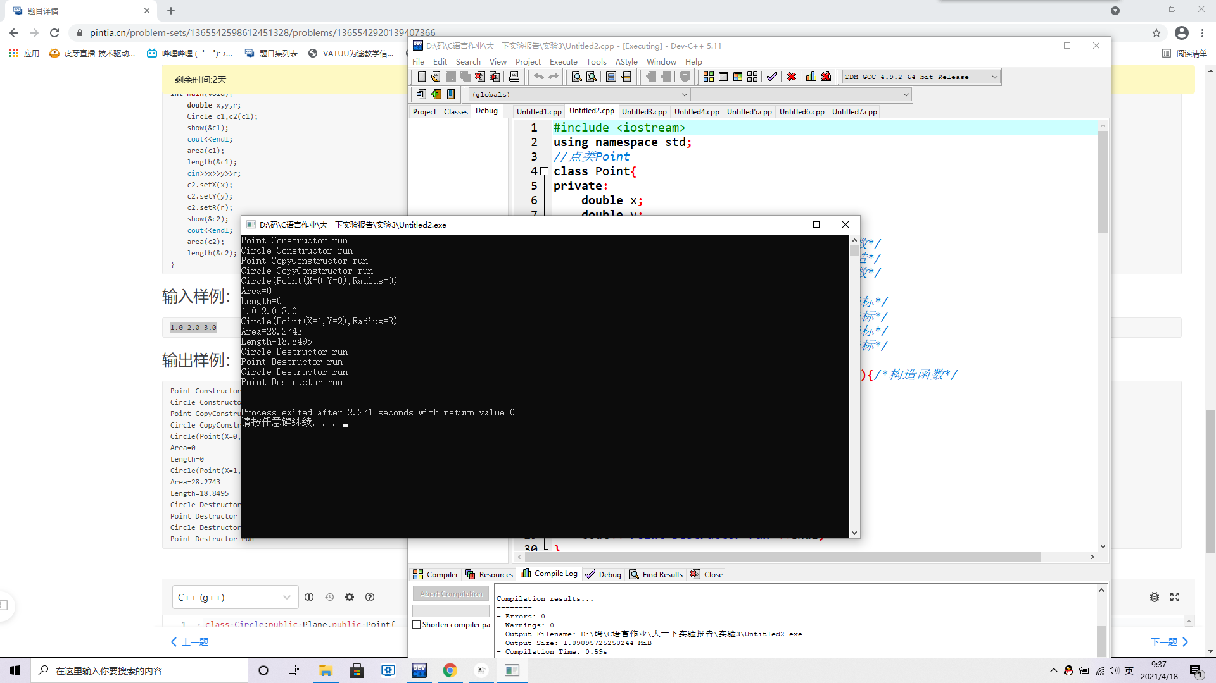
（四）、以点类Point及平面图形类Plane为基础设计三角形类Triangle【CPP0026】
【源代码】
此处附上完整的程序源代码，要求包括Person类、Student类、Teacher类和main()，要有必要的注释，不能是图片形式。
#include <iostream>
#include<cmath>
using namespace std;
//点类Point
class Point{
private:
double x;
double y;
public:
Point(double xv=0,double yv=0);/*构造函数*/
Point(const Point &p); /*拷贝构造*/
~Point(); /*析构函数*/
virtual void show()const; /*显示*/
void setX(double xv); /*设置X坐标*/
void setY(double yv); /*设置Y坐标*/
double getX() const; /*获取X坐标*/
double getY() const; /*获取Y坐标*/
};
Point::Point(const double xv,const double yv){/*构造函数*/
x=xv;
y=yv;
cout<<"Point Constructor run"<<endl;
}
Point::Point(const Point &p){/*拷贝构造*/
x=p.x;
y=p.y;
cout<<"Point CopyConstructor run"<<endl;
}
Point::~Point(){/*析构函数*/
cout<<"Point Destructor run"<<endl;
}
void Point::show() const{/*显示*/
cout<<"Point(X="<<x<<",Y="<<y<<")";
}
void Point::setX(double xv){/*设置X坐标*/
x=xv;
}
void Point::setY(double yv){/*设置Y坐标*/
y=yv;
}
double Point::getX() const{/*获取X坐标*/
return x;
}
double Point::getY() const{/*获取Y坐标*/
return y;
}
class Plane{/*平面图形基类*/
public:
virtual double length()const=0;/*周长*/
virtual double area()const=0; /*面积*/
};

/*请在这里填写答案*/

class Triangle:public Plane{
private:
Point a;
Point b;
Point c;
public:
Triangle(const Point &a,const Point &b,const Point &c);
Triangle(const Triangle &);
~Triangle();
void setA(const Point &);//set point a;
Point getA()const;//get point a;
void setB(const Point &);//set point b;
Point getB()const;//get point b;
void setC(const Point &);//set point c;
Point getC()const;//get point c;
void show()const;
double area()const;
double length()const;
};
Triangle::Triangle(const Point &A=Point(0,0),const Point &B=Point(0,0),const Point &C=Point(0,0)):a(A),b(B),c(C)
{
cout<<"Triangle Constructor run"<<endl;
}
Triangle::Triangle(const Triangle &temp):a(temp.a),b(temp.b),c(temp.c)
{
cout<<"Triangle CopyConstructor run"<<endl;
}
Triangle::~Triangle(){
cout<<"Triangle Destructor run"<<endl;
}
void Triangle::setA(const Point &aa){
a.setX(aa.getX());
a.setY(aa.getY());
}
void Triangle::setB(const Point &bb){
b.setX(bb.getX());
b.setY(bb.getY());
}
void Triangle::setC(const Point &cc){
c.setX(cc.getX());
c.setY(cc.getY());
}
Point Triangle::getA()const{
return a;
}
Point Triangle::getB()const{
return b;
}
Point Triangle::getC()const{
return c;
}
void Triangle::show()const{
cout<<"Triangle(";
cout<<"A=";
a.show();
cout<<",";
cout<<"B=";
b.show();
cout<<",";
cout<<"C=";
c.show();
cout<<")";
}
double Triangle::area()const{
double A,B,C;
int sum=1;
if(sum++==1)
{
Point a1(a),b1(b);
A=sqrt((a1.getX()-b1.getX())*(a1.getX()-b1.getX())+(a1.getY()-b1.getY())*(a1.getY()-b1.getY()));
}
if(sum++==2)
{
Point a1(a),c1(c);
B=sqrt((a1.getX()-c1.getX())*(a1.getX()-c1.getX())+(a1.getY()-c1.getY())*(a1.getY()-c1.getY()));
}
if(sum++==3)
{
Point c1(c),b1(b);
C=sqrt((c1.getX()-b1.getX())*(c1.getX()-b1.getX())+(c1.getY()-b1.getY())*(c1.getY()-b1.getY()));
}
double P=(A+B+C)/2;
return sqrt(P*(P-A)*(P-B)*(P-C));
}
double Triangle::length()const{
double A,B,C;
Point ax(a),ay(a);
Point bx(b),by(b);
Point cx(c),cy(c);
A=sqrt((ax.getX()-bx.getX())*(ax.getX()-bx.getX())+(ay.getY()-by.getY())*(ay.getY()-by.getY()));
B=sqrt((ax.getX()-cx.getX())*(ax.getX()-cx.getX())+(ay.getY()-cy.getY())*(ay.getY()-cy.getY()));
C=sqrt((cx.getX()-bx.getX())*(cx.getX()-bx.getX())+(cy.getY()-by.getY())*(cy.getY()-by.getY()));
return A+B+C;
}

void length(Plane *p){/*平面图形的周长函数*/
cout<<"Length="<<p->length()<<endl;
}
void area(Plane &p){/*平面图形的面积函数*/
cout<<"Area="<<p.area()<<endl;
}
//主函数
int main(void){
double x,y;
Point p1,p2(1,1),p3(2,2);
Triangle t1,t2(t1);
t1.show();
cout<<endl;
area(t1);
length(&t1);
cin>>x>>y;
p1.setX(x);
p1.setY(y);
t2.setA(p1);
t2.setB(p2);
t2.setC(p3);
t2.show();
cout<<endl;
area(t2);
length(&t2);
return 0;
}
【运行测试】
此处附上程序运行的测试截图
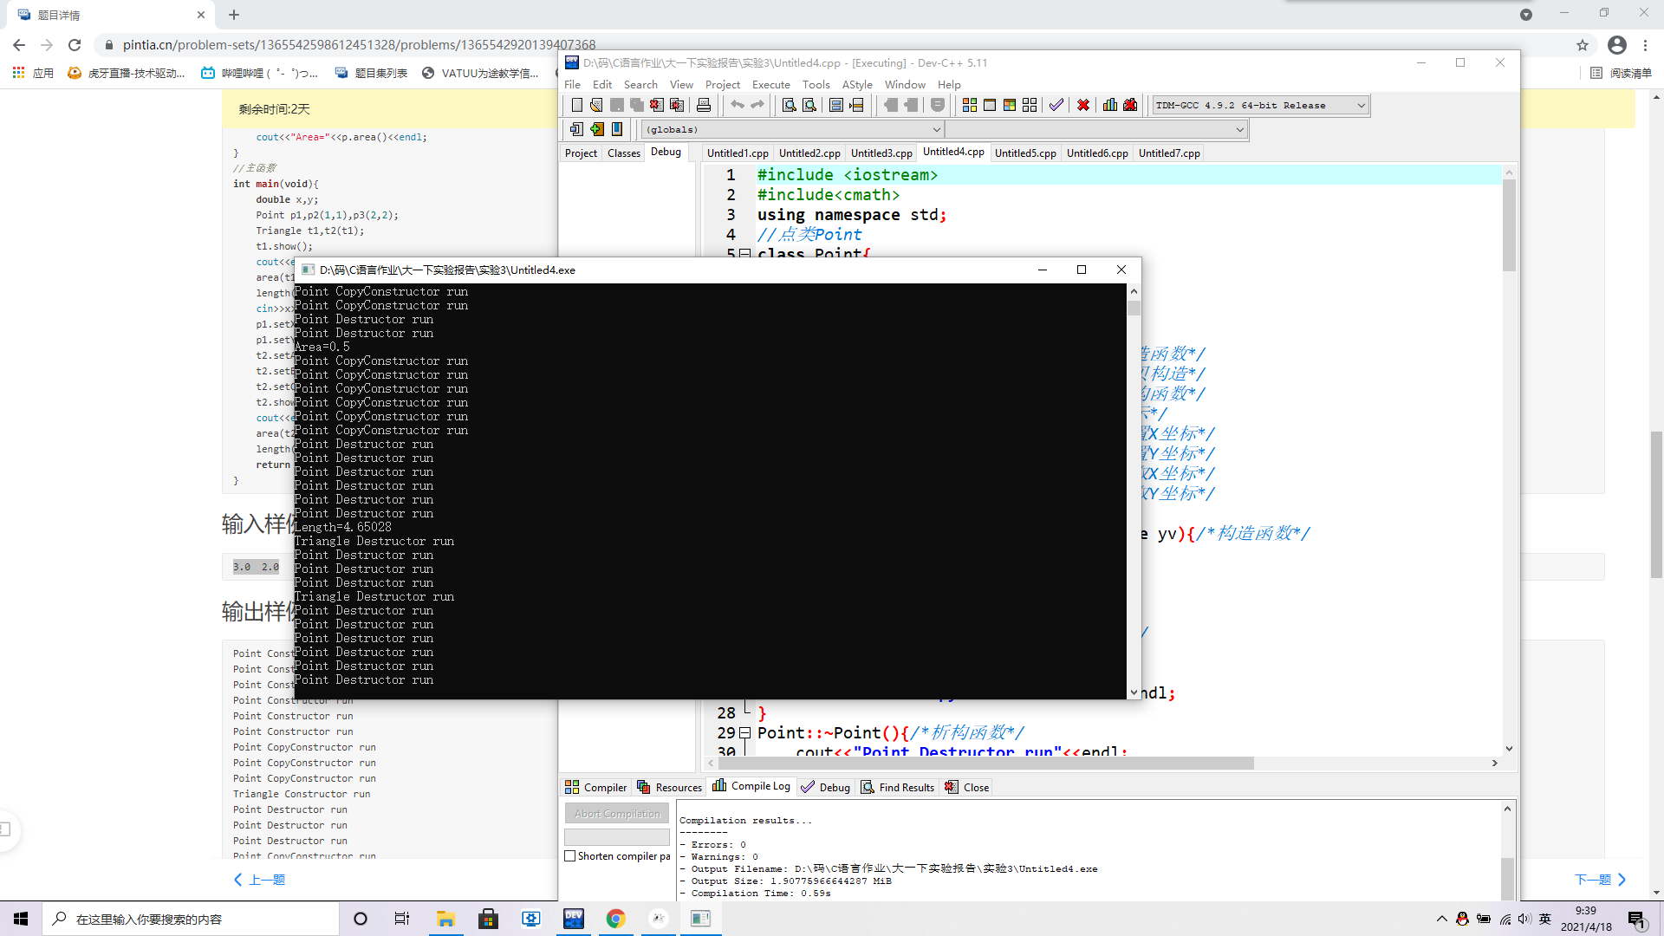
（五）、以圆类Circle及立体图形类Solid为基础设计球类Sphere【CPP0027】
【源代码】
此处附上完整的程序源代码，要求包括Person类、Student类、Teacher类和main()，要有必要的注释，不能是图片形式。
#include <iostream>
using namespace std;
//点类Point
class Point{
private:
double x;
double y;
public:
Point(double xv=0,double yv=0);/*构造函数*/
Point(const Point &p); /*拷贝构造*/
~Point(); /*析构函数*/
void setX(double xv); /*设置X坐标*/
void setY(double yv); /*设置Y坐标*/
double getX()const; /*获取X坐标*/
double getY()const; /*获取Y坐标*/
virtual void show()const; /*显示*/
};
Point::Point(const double xv,const double yv){/*构造函数*/
x=xv;
y=yv;
cout<<"Point Constructor run"<<endl;
}
Point::Point(const Point &p){/*拷贝构造*/
x=p.x;
y=p.y;
cout<<"Point CopyConstructor run"<<endl;
}
Point::~Point(){/*析构函数*/
cout<<"Point Destructor run"<<endl;
}
void Point::setX(double xv){/*设置X坐标*/
x=xv;
}
void Point::setY(double yv){/*设置Y坐标*/
y=yv;
}
double Point::getX()const{/*获取X坐标*/
return x;
}
double Point::getY()const{/*获取Y坐标*/
return y;
}
void Point::show()const{/*显示*/
cout<<"Point(X="<<x<<",Y="<<y<<")";
}
//平面图形类Plane
class Plane{
public:
virtual double length()const=0;/*周长*/
virtual double area()const=0; /*面积*/
};
//立体图形类Solid
class Solid{
public:
virtual double volume()const=0;/*体积*/
virtual double s_Area()const=0;/*表面积*/
};

/*请在这里填写答案*/

class Circle:public Point,public Plane{
private:
double x,y;
double radius;
protected:
static double PI;
public:
Circle(double x=0,double y=0,double r=0):Point(x,y){
radius=r;
cout<<"Circle Constructor run"<<endl;
}
Circle(const Circle &t):Point(t){
radius=t.radius;
cout<<"Circle CopyConstructor run"<<endl;
}
~Circle(){
cout<<"Circle Destructor run"<<endl;
}
void setR(double r){
radius=r;
}
double getR() const{
return radius;
}
void show() const{
cout<<"Circle(Point(X="<<getX()<<",Y="<<getY()<<"),Radius="<<radius<<")";
}
double area() const{
return PI*radius*radius;
}
double length() const{
return 2*PI*radius;
}
};
double Circle::PI=3.14159;
class Sphere:public Circle,public Solid{
private:
double x,y,radius;
public:
Sphere(double x=0,double y=0,double r=0):Circle(x,y,r){
cout<<"Sphere Constructor run"<<endl;
}
Sphere(const Sphere &t):Circle(t){
cout<<"Sphere CopyConstructor run"<<endl;
}
~Sphere(){
cout<<"Sphere Destructor run"<<endl;
}
void show() const{
cout<<"Sphere(Circle(Point(X="<<getX()<<",Y="<<getY()<<"),Radius="<<getR()<<"))";
}
double s_Area()const{
return 4*PI*getR()*getR();
}
double volume()const{
return 4*PI*getR()*getR()*getR()/3;
}
};
void show(Point *p){/*点基类的显示函数*/
p->show();
}
void length(Plane *p){/*平面图形的周长函数*/
cout<<"Length="<<p->length()<<endl;
}
void area(Plane &p){/*平面图形的面积函数*/
cout<<"Area="<<p.area()<<endl;
}

void volumn(Solid *s){/*立体图形的体积函数*/
cout<<"Volumn="<<s->volume()<<endl;
}
void s_Area(Solid &s){/*立体图形的表面积函数*/
cout<<"S_Area="<<s.s_Area()<<endl;
}
//主函数
int main(void){
double r;
cin>>r;
Sphere s1(1,2,3),s2(s1);
show(&s1);
cout<<endl;
area(s1);
length(&s1);
s_Area(s1);
volumn(&s1);
s2.setR(r);
show(&s2);
cout<<endl;
area(s2);
length(&s2);
s_Area(s2);
volumn(&s2);
return 0;
}
【运行测试】
此处附上程序运行的测试截图
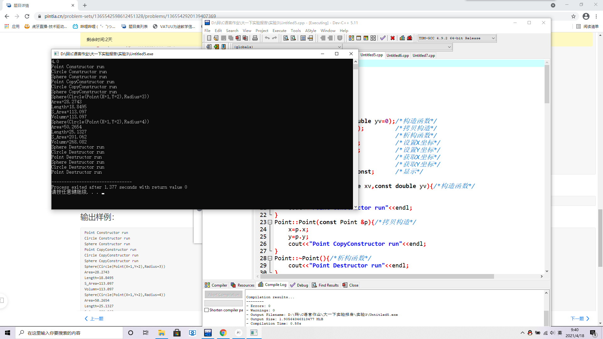
（六）、以圆类Circle及立体图形类Solid为基础设计圆柱类Cylinder【CPP0028】
【源代码】
此处附上完整的程序源代码，要求包括Person类、Student类、Teacher类和main()，要有必要的注释，不能是图片形式。
#include <iostream>
using namespace std;
//点类Point
class Point{
private:
double x;
double y;
public:
Point(double xv=0,double yv=0);/*构造函数*/
Point(const Point &p); /*拷贝构造*/
~Point(); /*析构函数*/
void setX(double xv); /*设置X坐标*/
void setY(double yv); /*设置Y坐标*/
double getX()const; /*获取X坐标*/
double getY()const; /*获取Y坐标*/
virtual void show()const; /*显示*/
};
Point::Point(const double xv,const double yv){/*构造函数*/
x=xv;
y=yv;
cout<<"Point Constructor run"<<endl;
}
Point::Point(const Point &p){/*拷贝构造*/
x=p.x;
y=p.y;
cout<<"Point CopyConstructor run"<<endl;
}
Point::~Point(){/*析构函数*/
cout<<"Point Destructor run"<<endl;
}
void Point::setX(double xv){/*设置X坐标*/
x=xv;
}
void Point::setY(double yv){/*设置Y坐标*/
y=yv;
}
double Point::getX()const{/*获取X坐标*/
return x;
}
double Point::getY()const{/*获取Y坐标*/
return y;
}
void Point::show()const{/*显示*/
cout<<"Point(X="<<x<<",Y="<<y<<")";
}
//平面图形类Plane
class Plane{
public:
virtual double length()const=0;/*周长*/
virtual double area()const=0; /*面积*/
};
//立体图形类Solid
class Solid{
public:
virtual double volume()const=0;/*体积*/
virtual double s_Area()const=0;/*表面积*/
};

/*请在这里填写答案*/

class Circle:public Point,public Plane{
private:
double x,y,radius;
protected:
static double PI;
public:
Circle(double x=0,double y=0,double r=0):Point(x,y){
radius=r;
cout<<"Circle Constructor run"<<endl;
}
Circle(const Circle &t):Point(t){
radius=t.radius;
cout<<"Circle CopyConstructor run"<<endl;
}
~Circle(){
cout<<"Circle Destructor run"<<endl;
}
void setR(double r){
radius=r;
}
double getR() const{
return radius;
}
void show() const{
cout<<"Circle(Point(X="<<getX()<<",Y="<<getY()<<"),Radius="<<radius<<")";
}
double area() const{
return PI*radius*radius;
}
double length() const{
return 2*PI*radius;
}
};
double Circle::PI=3.14159;

class Cylinder:public Circle,public Solid{
private:
double x,y,radius,height;
public:
Cylinder(double x,double y,double r,double h):Circle(x,y,r){
height=h;
cout<<"Cylinder Constructor run"<<endl;
}
Cylinder(const Cylinder &zcy):Circle(zcy){
height=zcy.height;
cout<<"Cylinder CopyConstructor run"<<endl;
}
~Cylinder(){
cout<<"Cylinder Destructor run"<<endl;
}
void setH(double h){
height=h;
}
double getH() const{
return height;
}
void show() const{
cout<<"Cylinder(Circle(Point(X="<<getX()<<",Y="<<getY()<<"),Radius="<<getR()<<"),Height="<<getH()<<")";
}
double s_Area()const{
double ar,lh;
ar=2*(Circle::area());
lh=Circle::length();
ar+=(lh*getH());
return ar;
}
double volume()const{
double ar;
ar=Circle::area();
return ar*getH();
}
};
void show(Point *p){/*点基类的显示函数*/
p->show();
}
void length(Plane *p){/*平面图形的周长函数*/
cout<<"Length="<<p->length()<<endl;
}
void area(Plane &p){/*平面图形的面积函数*/
cout<<"Area="<<p.area()<<endl;
}

void volumn(Solid *s){/*立体图形的体积函数*/
cout<<"Volumn="<<s->volume()<<endl;
}
void s_Area(Solid &s){/*立体图形的表面积函数*/
cout<<"S_Area="<<s.s_Area()<<endl;
}
//主函数
int main(void){
double h;
cin>>h;
Cylinder cy1(1,2,3,4),cy2(cy1);
show(&cy1);
cout<<endl;
area(cy1);
length(&cy1);
s_Area(cy1);
volumn(&cy1);
cy2.setH(h);
show(&cy2);
cout<<endl;
area(cy2);
length(&cy2);
s_Area(cy2);
volumn(&cy2);
return 0;
}
【运行测试】
此处附上程序运行的测试截图
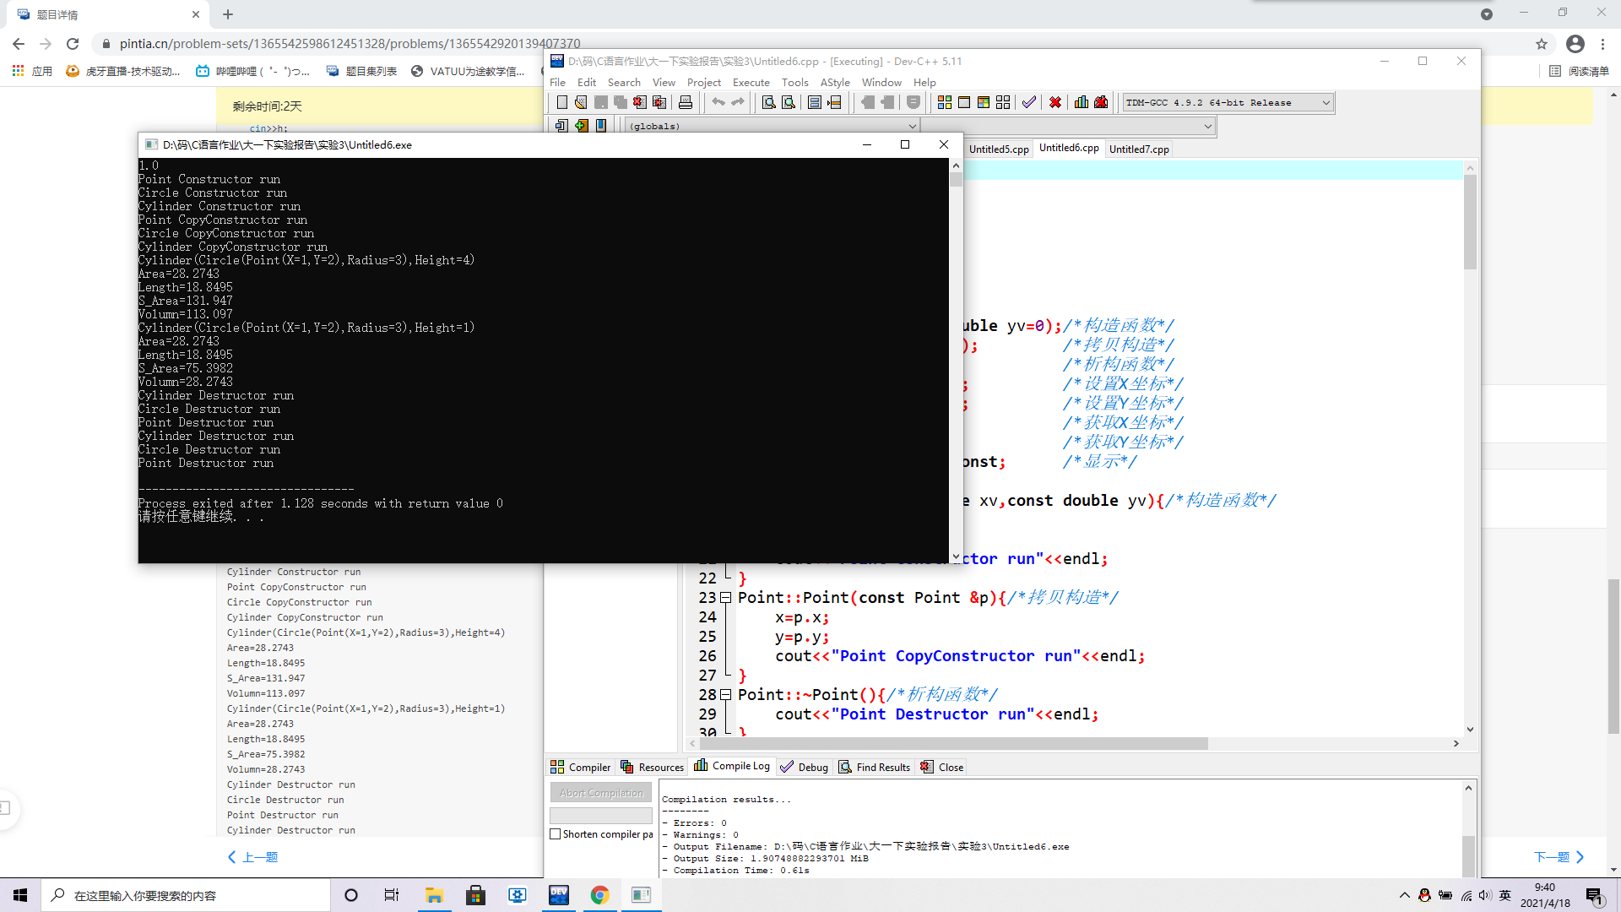
（七）、以圆类Circle及立体图形类Solid为基础设计圆锥类Cone【CPP0029】
【源代码】
此处附上完整的程序源代码，要求包括Person类、Student类、Teacher类和main()，要有必要的注释，不能是图片形式。
#include <iostream>
#include<cmath>
using namespace std;
//点类Point
class Point{
private:
double x;
double y;
public:
Point(double xv=0,double yv=0);/*构造函数*/
Point(const Point &p); /*拷贝构造*/
~Point(); /*析构函数*/
void setX(double xv); /*设置X坐标*/
void setY(double yv); /*设置Y坐标*/
double getX()const; /*获取X坐标*/
double getY()const; /*获取Y坐标*/
virtual void show()const; /*显示*/
};
Point::Point(const double xv,const double yv){/*构造函数*/
x=xv;
y=yv;
cout<<"Point Constructor run"<<endl;
}
Point::Point(const Point &p){/*拷贝构造*/
x=p.x;
y=p.y;
cout<<"Point CopyConstructor run"<<endl;
}
Point::~Point(){/*析构函数*/
cout<<"Point Destructor run"<<endl;
}
void Point::setX(double xv){/*设置X坐标*/
x=xv;
}
void Point::setY(double yv){/*设置Y坐标*/
y=yv;
}
double Point::getX()const{/*获取X坐标*/
return x;
}
double Point::getY()const{/*获取Y坐标*/
return y;
}
void Point::show()const{/*显示*/
cout<<"Point(X="<<x<<",Y="<<y<<")";
}
//平面图形类Plane
class Plane{
public:
virtual double length()const=0;/*周长*/
virtual double area()const=0; /*面积*/
};
//立体图形类Solid
class Solid{
public:
virtual double volume()const=0;/*体积*/
virtual double s_Area()const=0;/*表面积*/
};

/*请在这里填写答案*/

class Circle:public Point,public Plane{
private:
double x,y;
double radius;
protected:
static double PI;
public:
Circle(double x=0,double y=0,double r=0):Point(x,y){
radius=r;
cout<<"Circle Constructor run"<<endl;
}
Circle(const Circle &t):Point(t){
radius=t.radius;
cout<<"Circle CopyConstructor run"<<endl;
}
~Circle(){
cout<<"Circle Destructor run"<<endl;
}
void setR(double r){
radius=r;
}
double getR() const{
return radius;
}
void show() const{
cout<<"Circle(Point(X="<<getX()<<",Y="<<getY()<<"),Radius="<<radius<<")";
}
double area() const{
return PI*radius*radius;
}
double length() const{
return 2*PI*radius;
}
};
double Circle::PI=3.14159;
class Cone:public Circle,public Solid{
private:
double x,y,radius,height;
public:
Cone(double x,double y,double r,double h):Circle(x,y,r){
height=h;
cout<<"Cone Constructor run"<<endl;
}
Cone(const Cone &zcy):Circle(zcy){
height=zcy.height;
cout<<"Cone CopyConstructor run"<<endl;
}
~Cone(){
cout<<"Cone Destructor run"<<endl;
}
void setH(double h){
height=h;
}
double getH() const{
return height;
}
void show() const{
cout<<"Cone(Circle(Point(X="<<getX()<<",Y="<<getY()<<"),Radius="<<getR()<<"),Height="<<getH()<<")";
}
double s_Area() const{
double ar,l,R,H;
ar=Circle::area();
R=Circle::getR();
H=getH();
l=sqrt(H*H+R*R);
return ar+PI*R*l;
}
double volume() const{
double ar;
ar=Circle::area();
return ar*getH()/3;
}
};

void show(Point *p){/*点基类的显示函数*/
p->show();
}
void length(Plane *p){/*平面图形的周长函数*/
cout<<"Length="<<p->length()<<endl;
}
void area(Plane &p){/*平面图形的面积函数*/
cout<<"Area="<<p.area()<<endl;
}

void volumn(Solid *s){/*立体图形的体积函数*/
cout<<"Volumn="<<s->volume()<<endl;
}
void s_Area(Solid &s){/*立体图形的表面积函数*/
cout<<"S_Area="<<s.s_Area()<<endl;
}
//主函数
int main(void){
double h;
cin>>h;
Cone co1(1,2,3,4),co2(co1);
show(&co1);
cout<<endl;
area(co1);
length(&co1);
s_Area(co1);
volumn(&co1);
co2.setH(h);
show(&co2);
cout<<endl;
area(co2);
length(&co2);
s_Area(co2);
volumn(&co2);
return 0;
}
【运行测试】
此处附上程序运行的测试截图
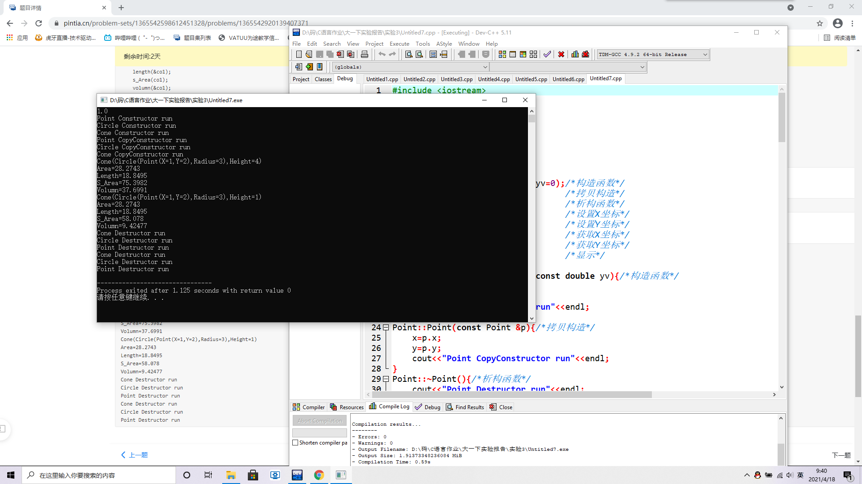
四 实验分析及问题思考
1、分析并总结静态多态和动态多态的实现方法与作用区别；【CPP0030】
【答案】此处附上问题答案
代码：class Solid{
public:
virtual double volume()const=0;/*体积*/
virtual double s_Area()const=0;/*表面积*/
};
class Cone:public Circle,public Solid{
private:
double x,y,radius,height;
public:
Cone(double x,double y,double r,double h):Circle(x,y,r){
height=h;
cout<<"Cone Constructor run"<<endl;
}
Cone(const Cone &zcy):Circle(zcy){
height=zcy.height;
cout<<"Cone CopyConstructor run"<<endl;
}
~Cone(){
cout<<"Cone Destructor run"<<endl;
}
void setH(double h){
height=h;
}
double getH() const{
return height;
}
void show() const{
cout<<"Cone(Circle(Point(X="<<getX()<<",Y="<<getY()<<"),Radius="<<getR()<<"),Height="<<getH()<<")";
}
double s_Area() const{
double ar,l,R,H;
ar=Circle::area();
R=Circle::getR();
H=getH();
l=sqrt(H*H+R*R);
return ar+PI*R*l;
}
double volume() const{
double ar;
ar=Circle::area();
return ar*getH()/3;
}
};
静态多态： 编译阶段确定函数地址，如代码中Cone类内的show函数，getH函数等，作用：有很强的适配性和松耦合性，比如可以通过偏特化、全特化来处理特殊类型
动态多态：运行过程中确定函数地址 ，如代码中Cone类内的s_Area()函数，作用：处理同一继承体系下异质对象集合的强大威力，实现与接口分离，可复用
C++多态编程(10003809173j)
班级:信2007-2 学号:20203907 姓名:周朝勇
实验自评
实验内容 |  | 自评结果（在对应格内打✓）
 |  | 熟练 | 比较熟练 | 一般 | 不熟练
多重继承【CPP0031】 |  |  | ✓
多态 | 多态实现方式【CPP0032】 |  | ✓
多态 | 运算符重载【CPP0033】 |  | ✓
多态 | 虚函数【CPP0034】 | ✓
多态 | 虚函数与抽象类【CPP0035】 |  | ✓
实验体会
此部分要求据实填写
体会到两种多态，静态和动态分别的优点和缺点，各自的实现方式

